CARD SCAN INFORMATION
Thank you for choosing Above Biometrics for your card scan needs.
Please follow these directions to process your fingerprint card.

Please send your signed FD-258 FBI card to:
Above Biometrics
Attn: Card Scan
1363 Green Knolls Drive
Buffalo Grove, IL 60089

Please include the following:
- Check for $65 or included credit card information sheet
If you would prefer a call to pay, please include your best contact number.
- Also, let us know if you would prefer text or email for your TCN# and your credit card receipt.

- Your Cell number or your email address

- Any paperwork required for the state

CREDIT CARD AUTHORIZATION FORM

Cardholder Name:

_________________________Signature: ________________________

Phone Number: ____________________________
Email Address: _____________________________________________________
Credit Card Number:
________ - ________ - ________ - ________

Expiration ________ / ________

Billing Zip Code: ________
CVV Number (last 3 digits on the back or 4 digits on front of AMEX): ________
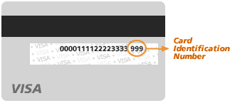
Amount Charged: $ ________________ (USD)
Apply Amount to: Invoice# ___________________

Send the authorization to:
jay@abovebiometrics.com
or in with your FBI card mailing

