ESSENTIAL SECURITY SOLUTIONS LLC
In the security industry there are two different kinds of surveillance cameras, IP and Analog. IP Cameras offer the absolute latest and greatest in video surveillance technology with the highest resolution video and advanced remote viewing capability. Analog is based upon older standards, and while less expensive than IP, analog can afford you a much lower resolution image, slower performance and less reliability.
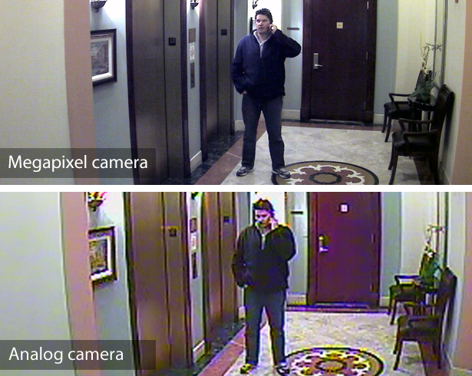
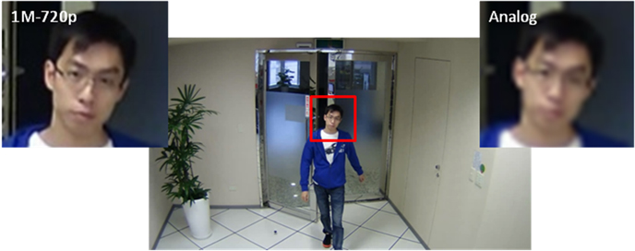
As you can clearly see, this is why we strongly recommend IP to our customers. The difference in quality can be the deciding factor of a criminal being caught or not.
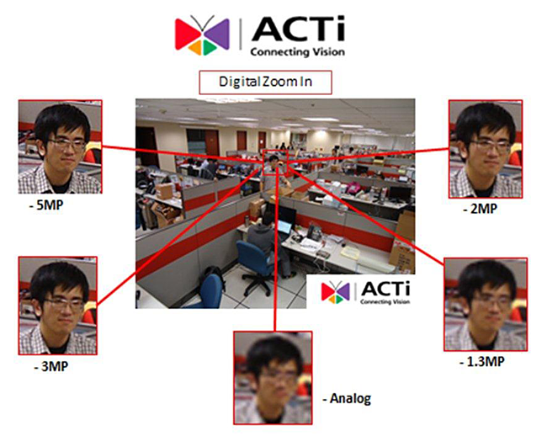
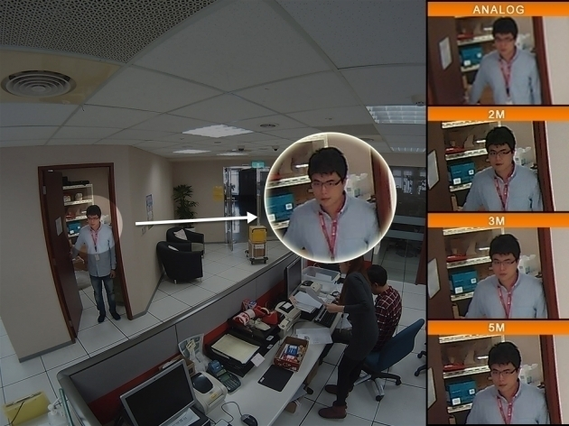
Essential Security Solutions can provide you with the right camera to suit your needs, be it a high-definition vandal-proof PTZ camera or a small, undetectable nanny-cam to check up on the babysitter. With IP camera technology you can be rest-assured that you are getting a modern, reliable camera that can pick up all of the important detail in up to 1080p resolution
Have More Questions? Contact us Today for a Free Security Review!
Phone: 1-855-449-SAFE (7233)
Email us: information@essSafe.com
www.essSafe.com

