Tax Preparation Checklist & Process

In order to prepare your tax returns efficiently and on time, please provide all of the below
information in one package no later than March 1 (for businesses) and April 1 (for individuals):

• Signed engagement letter
• Completed tax organizer
• Copy of current driver’s license (required starting in 2016 for e‐file to combat identity theft)
• Copies of all official tax documents received (W‐2s, 1099s, 1098s, 1095s, K‐1s, etc.)
• Copies of any other tax‐related documents
• Voided check for direct deposit and/or direct debit of tax refunds or balances owed
• For all businesses (sole proprietorships, partnerships, and corporations):
o Current year profit & loss statement on the cash basis (unless an accrual basis taxpayer
for tax purposes)
o Start of year and end of year balance sheet on the cash basis (unless an accrual basis
taxpayer for tax purposes)
o Current year trial balance
o Listing of all business assets purchased with an expected life of more than one year
with date of purchase, description, and amount
o NOTE: If you or your business has a requirement to file W‐2s or 1099s, please provide
the information required to file them no later than January 25, 2017. We offer a
seamless service that also mails copies to the employee or contractor.

We will only begin completion of your tax returns once we receive all of the above items. Upon
receipt of your information, it will take us generally 7‐10 days to do an initial draft of your tax
returns. We strongly encourage the use of our secure web portal at
http://inauguralaccountinggroup.sharefile.com for the exchange of tax documents. If you want to be added to
the system, or need your password reset on an existing account, please let us know.

Once we have the initial draft, we will likely submit a list of additional information and/or
documents needed. Please only send the responses once you have all of the information. This will
allow us to be more efficient in completing your work.

Within 7‐10 days of receiving any required supplemental information, the final tax returns will be
ready. We will release them for your review and issue an invoice for the tax return preparation
fee. We cannot e‐file any returns without your signature on the required e‐file authorization
forms. Once we have received your signed e‐file authorizations, we will e‐file the tax returns.

If there is a problem with the e‐filing of the returns, we will promptly let you know; otherwise, you
can safely assume the returns were transmitted and accepted by the IRS and/or state.

Tax Preparation Services Engagement Letter

Inaugural Accounting Group will prepare your 2016 federal and state of residence tax returns based on the
information and tax forms that you provide. If you are required to file additional state tax returns, or local
tax returns, you agree to notify us of those filing requirements.

We will provide you a tax organizer in order to assist you with gathering all relevant information; therefore,
you agree to complete the tax organizer accurately and to the best of your ability. You affirm that all
information provided is accurate and that you have all required supporting documentation. If you are
unsure of the required documentation, we can provide advice in that area. In some cases, we will ask to
review your documentation; however, we will not audit the documentation. Please note that you must be
able to provide written documentation of all items on the tax returns if examined by either the IRS or state
tax authority.

We will use our professional judgment in preparing your tax returns. If we are aware of unclear tax law or
conflicting interpretations of tax law, we will explain the possible positions and we will adopt whatever
position you request if it is consistent with relevant tax authority. If the IRS or state taxing authority later
contests the position taken, there may be an assessment of additional tax plus penalties and interest. We
assume no liability for any such assessments.

In order to file your tax returns timely, we need all required information no less than 15 days prior to the
deadline (March 1 for corporation returns, April 1 for individual and partnership returns). An extension
may be required if we do not receive all required information by the above dates. We do not file
extensions automatically for clients; as such, you must notify us in writing of your request. Please note that
an extension is an extension to file and not an extension to pay. Penalties and interest may accrue on any
tax balance unpaid prior to the return filing deadline. We can provide advice on the amount to be paid with
an extension.

You agree to review the tax returns carefully prior to filing in order to ensure the returns are accurate and
complete. The client review is an integral part of the quality control process. IRS regulations require
electronic filing of all eligible tax returns. If you prefer to file your tax return by paper, you must opt‐out in
writing.

If there is an omission from the tax returns, and you did not provide us the information prior to filing, then
we will amend the tax returns at our normal rates for amended tax returns. If there is an omission from the
tax returns, and you provided us the information prior to filing, then we will amend the tax return at no
cost to you.

The overall complexity of the tax returns and the time required for their completion determine the annual
tax preparation fee. This fee also includes basic tax consultation and planning services for the entire
calendar year. Please note it is at our sole discretion as to what consultation and planning services are
“basic.” Under a separate engagement letter, we can provide extensive tax planning or research services.
Invoices are payable within 30 days. Any unpaid invoices from prior engagements must be paid‐in‐full to
the initiation of this engagement.
Inaugural Accounting Group
2017 Tax Preparation Engagement Letter
Page 2 of 2

This engagement includes neither representation before the IRS or state authorities for examination or
collection matters nor bookkeeping services nor third party verification letters. Under a separate
engagement letter, we can provide additional services as needed.

It is your responsibility to report all foreign activities. You must inform us if you have income from foreign
sources, financial transactions with foreign persons and/or entities, or signature authority or a financial
interest in foreign financial accounts or assets. Please note that the penalties for noncompliance with
foreign activity reporting requirements are severe and could lead to criminal prosecution. We specialize in
international compliance and can assist with correcting prior non‐reporting.

We strive to protect your private information. As such, we provide a secure Internet portal as the preferred
means of exchanging tax documents. We strongly discourage the use of unsecured e‐mail to transmit tax
documents. We will not provide any confidential tax information to third parties unless authorized in
writing pursuant to Internal Revenue Code §7216.

In recognition of the relative risks and benefits of this agreement to both parties, you agree that any
liability for any negligent errors or omissions committed by us in the performance of the engagement will
be limited to three times the fee for this engagement. Both parties also agree that there is a one‐year
limitation period to bring a claim against us for errors and omissions. The one‐year period will begin upon
the date of the tax professional’s signature on the tax returns covered by this engagement letter.

We appreciate the opportunity to serve you and value you as a client. By signing below, you acknowledge
that you have read, understand, and accept your obligations and responsibilities, and that you understand
our responsibilities in preparing your tax returns as explained above. You also agree that if any provision of
this agreement is invalid or unenforceable, then all other provisions remain in full force and effect.

______________________________________________________________________________
Taxpayer Signature Print Name Date

______________________________________________________________________________
Spouse Signature Print Name Date

______________________________________________________________________________
Accepted & Agreed by Mekeisha T. Thomas on behalf of Inaugural Accounting Group

Tax Year
Tax Return Appointment:
Client Tax Organizer
Date:
Time:
Please complete this Organizer before your appointment. Include all statements (W-2s, 1099s, etc.)
1. Personal Information
First name & Initial
Last name
Social Security number
Date of birth
Occupation
E-mail address
Work phone
Home phone
Address
City
Cell
Fax
Taxpayer
Spouse
Work
Home
Cell
Fax
Apt/Suite
State
ZIP
Yes
Yes
Yes
No
No
No
...........
Taxpayer Disabled ...........
Pres. Campaign Fund (Taxpayer) ......
Taxpayer Legally Blind

Filing status: Single
Head of Household
Yes
Yes
Yes
No
No
No
.......
Spouse Disabled .........
Pres. Campaign Fund (Spouse) ..
Spouse Legally Blind
Married filing separate
Widower
Married filing joint
Year of Spouse death?
2. Dependents (Children & Others)
Name
Relationship
Date
of
Birth
Social
Security
Number
Months
Lived With
You Disabled
Full Time
Student
Dependent's
Gross
Income
Please answer the following questions to determine maximum deductions:
1. Did your marital status change
during the year?
2. Did your address change during the year?
3. Were there any changes in dependents?
4. Did you receive unreported tip income of
$20 or more in any month?
5. Did you receive any unemployment or
disability income?
6. Did you buy or sell any stocks, bonds or
other investment property?
7. Did you purchase, sell, or refinance your
principal home or second home, or take
out a home equity loan?
8. Did you convert part or all of your
traditional/SEP/SIMPLE IRA to a ROTH IRA?
9. Could you be claimed as a dependent on
another person's tax return?
10. Did you pay anyone for domestic
services in your home?
11. Did you pay anyone for childcare
services?
Yes
Yes
Yes
Yes
Yes
Yes
No
No
No
No
No
No
12. Did you receive a distribution from or
make a contribution to a retirement
plan (401(k), IRA, etc.)?
13 Did you give a gift of more than
$14,000 to one or more people?
14. Did you go through bankruptcy,
foreclosure, or repossession proceedings?
15. Did you incur a loss because of
damaged or stolen property?
16. Were you notified or audited by either
the IRS or State taxing agency?
17. Did you work from a home office or
use your car for business?
18. May the IRS discuss your tax return
with your preparer?
19 Were you a citizen of, have income
from, or live in a foreign country?
20. Do you want to electronically file
your tax return?
21. Did you buy any internet merchandise
for which you did not pay sales/use tax?
22. Health Insurance. Did you have ACA
compliant health insurance during the year?
(Attach Form 1095-A, 1095-B, and/or 1095-C)
Yes
Yes
Yes
Yes
Yes
Yes
Yes
Yes
Yes
Yes
Yes
No
No
No
No
No
No
No
No
No
No
No
Yes
Yes
Yes
Yes
Yes
No
No
No
No
No
.
Inaugural Accounting Group
8417 Crossland Loop
Montgomery, AL 36117
info@inauguralaccountinggroup.com

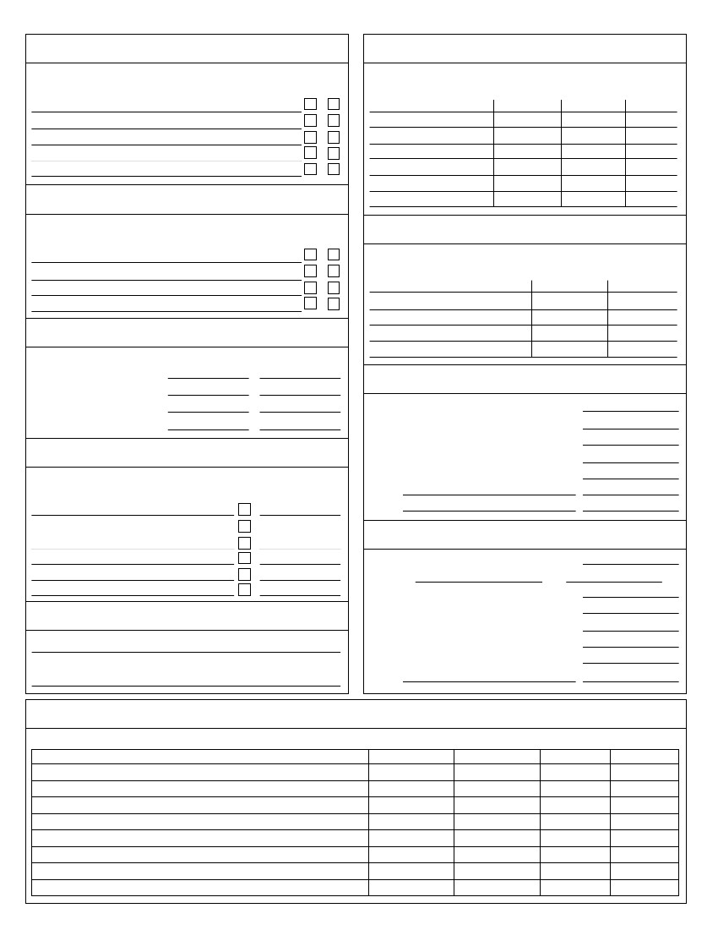3. Wage, Salary Income
Attach Form(s) W-2's
Employer name
TP
SP
8. Dividend Income
Attach Form(s) 1099-DIV
Form 1099-DIV Payer
Ordinary
Capital gain Tax-exempt?
4. Pensions, Annuities, Profit Sharing, IRA's, etc.
Attach Form(s) 1099-R
1099-R Payer name
TP
SP
9. Property Sold
Attach Form(s) 1099-S & closing statements
Property
Date acquired
Cost & Imp
5. Social Security/Railroad Benefits
Attach Form(s) SSA-1099
Social Security benefits
Railroad Retirement benefits
Medicare B premiums w/h
Medicare D premiums w/h
Taxpayer
Spouse
10. Other Income
.............
Gambling/lottery winnings........
Jury duty .................
Disability income .............
State income tax refund.........
Alimony received
Amount
Other
Other
6. Interest Income
Attach Form(s) 1099-INT & Broker statements
1099-INT Payer name
Tax-exempt?
11. Adjustments to Income
Alimony paid
Name
IRA/SEP Contributions - Taxpayer
................
SS#
7. Partnership, Trust, Estate Income
Attach Form(s) K-1
.....
IRA/SEP Contributions - Spouse ......
Educator expenses .............
Student loan interest ............
Health Savings Account..........
Other:
12. Investments Sold
Attach Form(s) 1099-B & confirmation slips
Investment
Date acquired
Date Sold
Cost
Sale Price

13. Medical/Dental Expenses
..
Long Term Care insurance ..........
Prescription drugs..............
Glasses, contacts..............
Hearing aids, batteries ............
Braces ....................
Medical equipment, supplies .........
Nursing care .................
Medical therapy...............
Hospital ...................
Doctor/Dental/Orthodontist ..........
Medical insurance premiums (paid by you)
Mileage
18. Charitable Contributions (receipts required)
...................
United Way................
Scouts ...................
Telethons.................
University, Public TV/Radio .........
Heart, Lung, Cancer, etc. ..........
Wildlife Fund., Humane society .......
Salvation Army, Goodwill ..........
Church
Other:
Non-Cash
Address
City/State/Zip
Value of goods (attach list if more than one)
14. Taxes Paid
Real property tax (attach bills)
Personal property tax
Other:
Volunteer mileage
.............
........
.............
19. Miscellaneous/Unreimbursed Expenses
.........
Books, subscriptions, supplies.......
Licenses ..................
Tools, equipment, safety equipment .....
Uniforms (including cleaning) ........
Sales expense, gifts............
Tuition, Books (work related) ........
Entertainment...............
Tax preparation fee............
Safe deposit box ..............
IRA custodial fees.............
Investment periodicals, advisory fees ....
Job search expense............
Moving of household goods (job related)..
Dues - union, professional
Other:
Other:
15. Interest Expense
Mortgage interest paid (attach 1098's)
....
Interest paid to individual for your home
(attach amortization schedule)
Paid to:
Name
Address
Social Security No.
Investment interest
..............
16. Casualty/Theft Loss
For property damaged by storm, water, fire, accident, or stolen.
Location of property
Description of property
20. Day Care Expense (Form 2441)
Provider #1
Address
City/State/ZIP
EIN/SS#
Provider #2
Address
City/State/ZIP
State
Amount
LY - Jan 15
Q1 - Apr 15
Q2 - Jun 15
Q3 - Sep 15
Q4 - Jan 15
EIN/SS#
Children cared for
Amt Pd
Amt Pd
Amount of damage
.............
Insurance reimbursement ..........
Repair costs................
Federal grants received ...........
17. Estimated Tax Payments
Federal
Amount
LY - Jan 15
Q1 - Apr 15
Q2 - Jun 15
Q3 - Sep 15
Q4 - Jan 15

Self Employment Information
Total Sales
Expenses
Advertising
Commissions/Fees
Dues & Publications
Interest Expense
Insurance
Legal & Professional Fees
Office Expense
Rent (office) Expense
Equipment Rental Expense
Auto Expense
Auto Mileage
Business Name
Taxpayer
Spouse
Repairs Expense
Supplies Expense
Taxes
Travel Expense
Meals & Entertainment
Telephone
Utilities
Wages (gross W-2)
Postage
Bank Charges
Tools & Equipment
Uniforms
Assets Purchased
DateAmount
Notes
Asset
Cost of Goods Sold
Inventory at beginning of year
Purchases
Cost of items for personal use
Cost of labor
Material & supplies
Other:
Other:
Inventory at end of year
Property #1
Property #2
Property #3
Property #4
Rental Income
Address
City/State
Rent Received
Expenses
Advertising
Auto & Travel
Auto Miles
Cleaning & Maintenance
Commissions Paid
Grounds & Gardening
Insurance
Interest Expense
Legal & Professional
Management Fees
Repairs & Maintenance
Supplies
Taxes
Utilities
Association Dues
Pest Control
Other:
Other:
Other:
Other:
Other:
Other:

