Shaw Farms Equine & Therapeutic Center “SFETC” 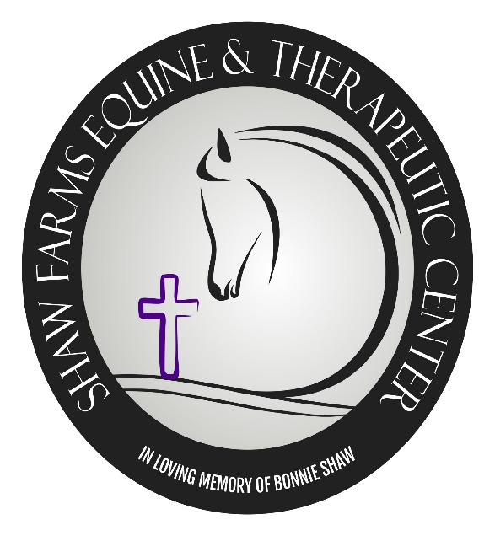

47002 Watson Rd

St. Clairsville, Ohio 43950

740-296-0067

www.shawfarmsequinetherapeuticcenter.com
SPONSOR COMMITMENT FORM

Sponsor Name:
Contact:
Address:

Phone:

Email Address:

The following is Sponsor’s Commitment:

GOLD - $500
Includes 8 event tickets which includes admission, dinner and non-alcoholic drinks
Displayed Banner in main arena and road-front listing Sponsors Name
Website listing event sponsors
Announcement during fundraiser event by band

SILVER - $250
Includes 4 event tickets which includes admission, dinner and non-alcoholic drinks
Website listing event sponsors
Announcement during fundraiser event by band

Donate materials for the auctions/drawings or in-kind to offer the event

Sponsor’s Signature: Date:

Sponsor packets and invoice will be mailed upon sponsor’s commitment.

